**REDCAP installation steps with pictures**

* Copy the webfolder from tsd to the webserver docker which is docker_webserver_1 using the command

docker cp webserver/redcap/ docker_webserver_1:/var/www/html

* Login to the docker webserver container with the command

docker exec -it docker_webserver_1 /bin/bash

* give write permission for the redcap folder

chmod -R 777 redcap/

from the browser, login to phpMyAdmin (localhost:9000) with the root user credentials – (root, norment123)

from the browser, localhost:8000/redcap/install.php

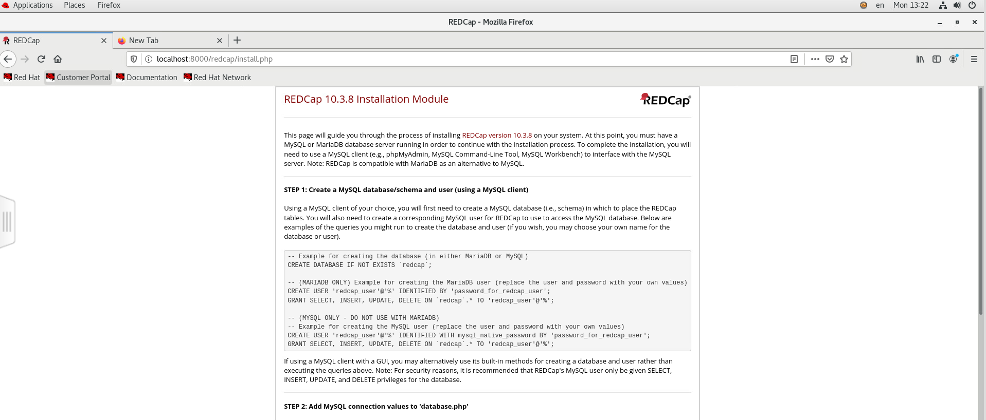

* copy the commands given under MYSQL

and paste in the mysql database and user table (using phpMyAdmin)

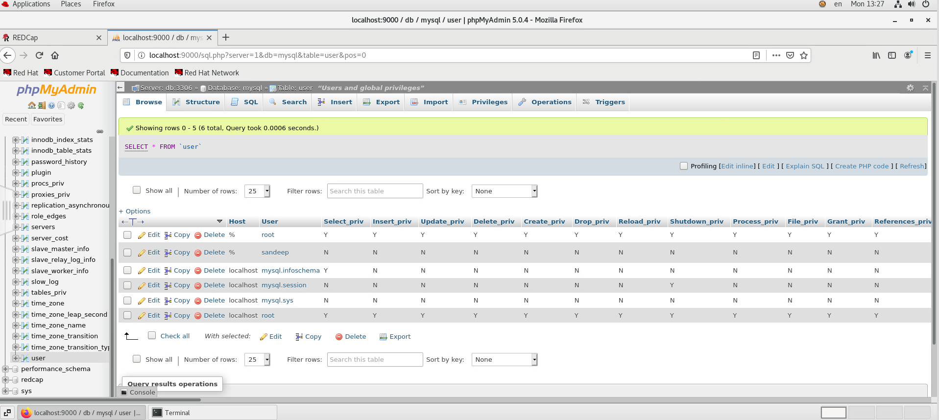

* Navigate to the SQL tab, paste the query, replace the dummy user name and password field in the query with – (norment_admin, norment123), same with the second sql query (replace the dummy username with norment_admin)

Refresh the page to execute step 2

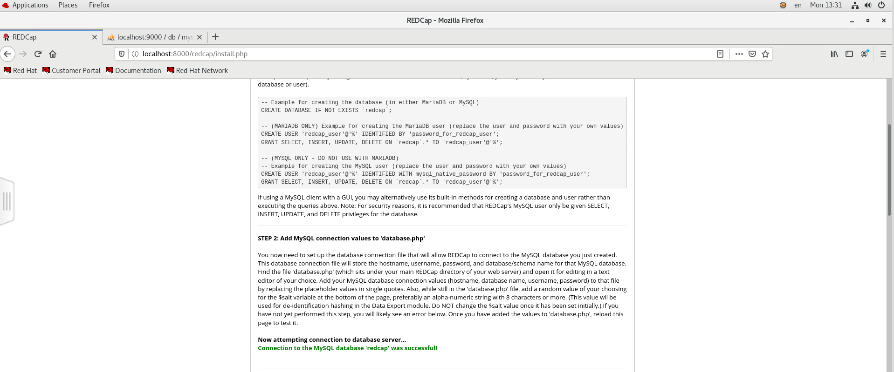

Once the connection to the database is successful, go to the next step – otherwise the problem would be in the database.php file in the redcap folder.

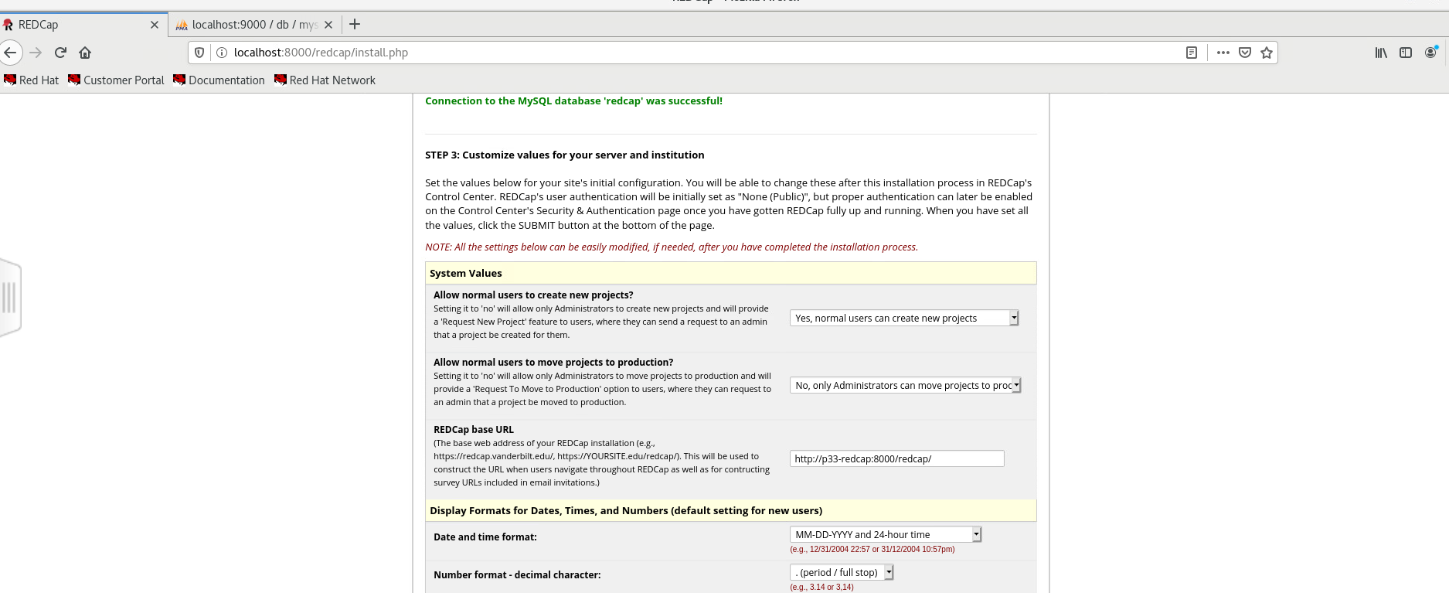

URL can be modified – right now it is set as p33-service-l.tsd.usit.no:8000/redcap/

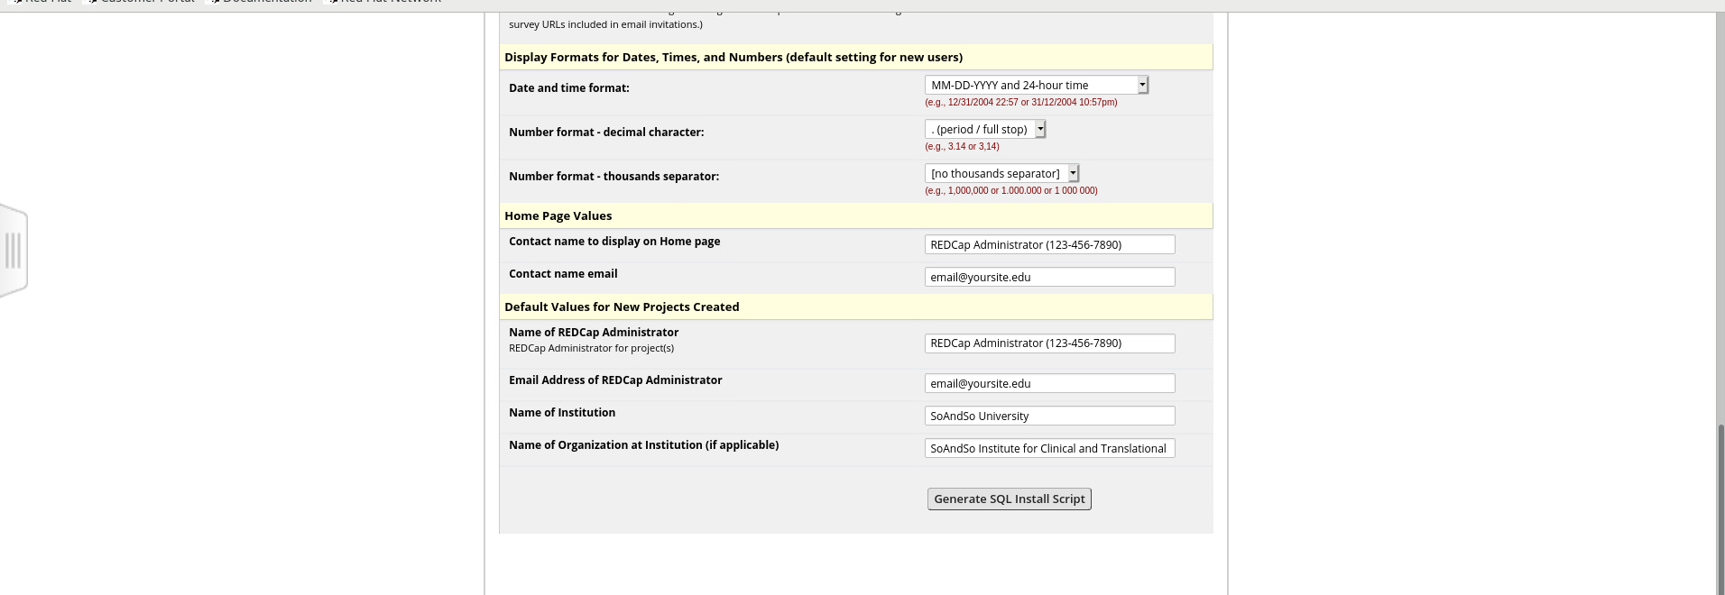

Click Generate SQL install script

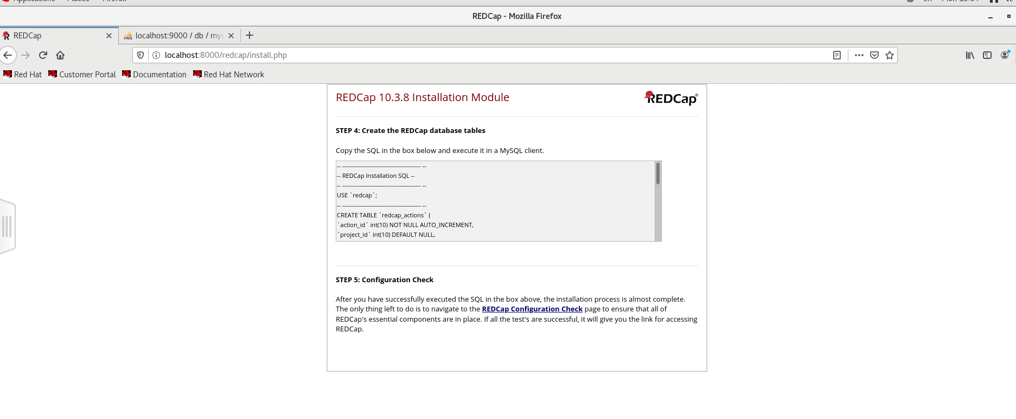

Copy all the queries in step 4 and execute on the redcap database using phpMyAdmin

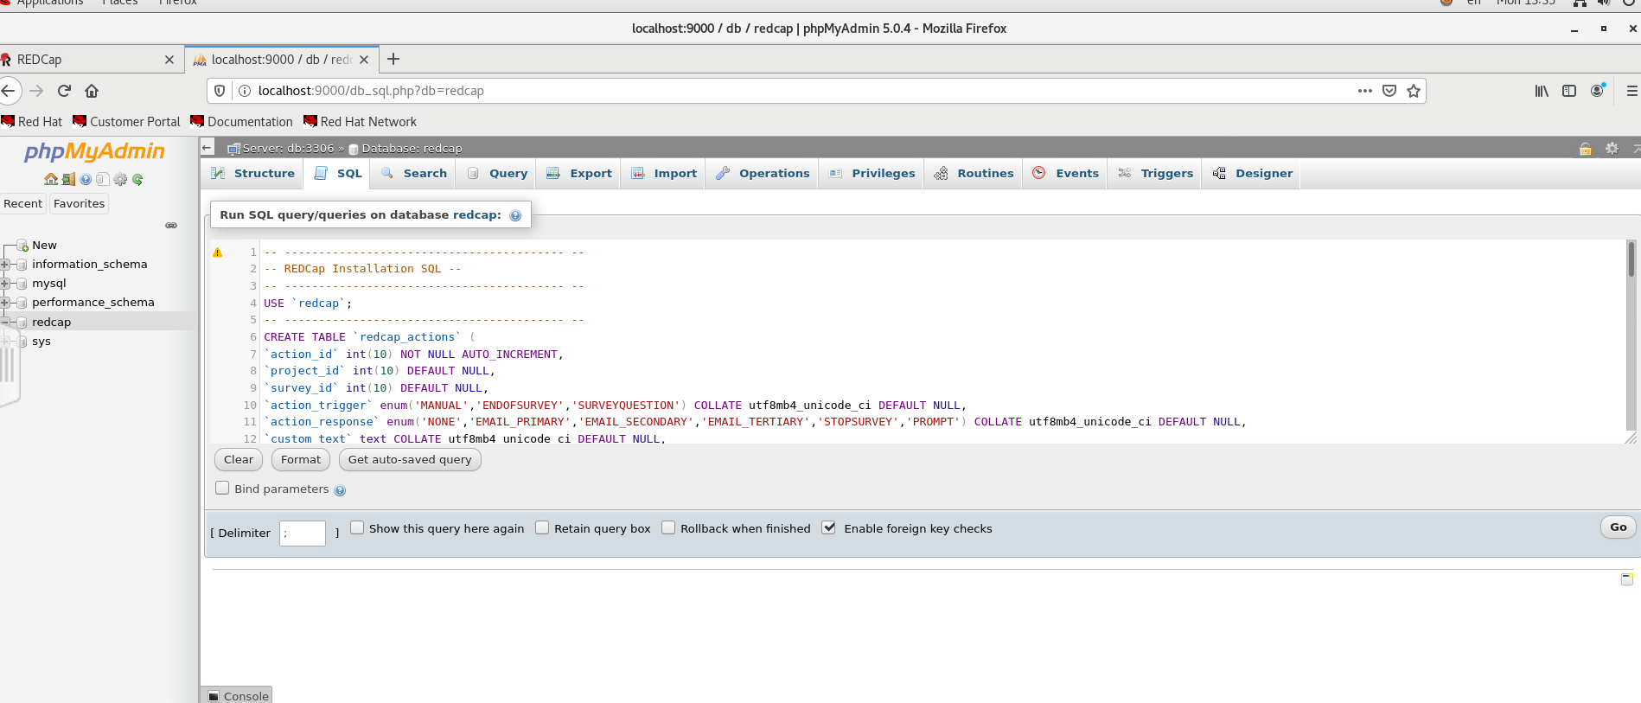

Click Go to execute the query, if there is no error you would get the output

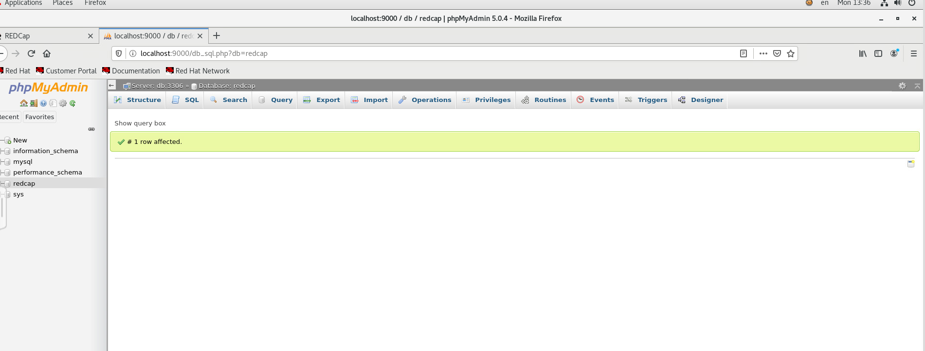

Proceed to step 5 and click the Redcap configuration check link



Some checks would fail because of internet, other thing to be resolved – cron jobs



The link p33-redcap didn’t work hence I had to use the hostname of the VM – p33-service-l.tsd.usit.no:8000/redcap/

